SQL DATABASE PROJECTS

CREATION OF MY OWNN DATABASES AND APPLYING QUERIES ON THEM

1. SQL SERVER

Basic Queries
- Retrieve all columns and rows from the cars table.
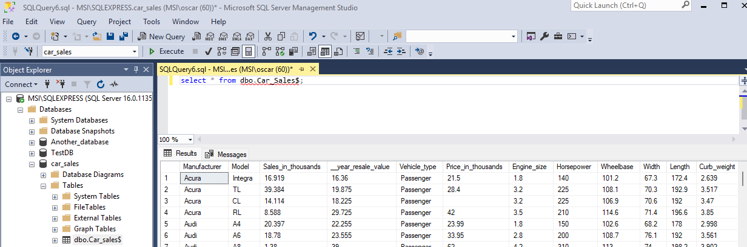
- Select the make and price of all cars.
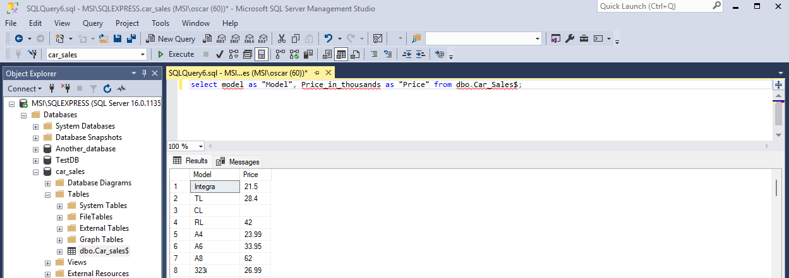
- Retrieve all cars that have a fuel efficiency of 15 or higher.
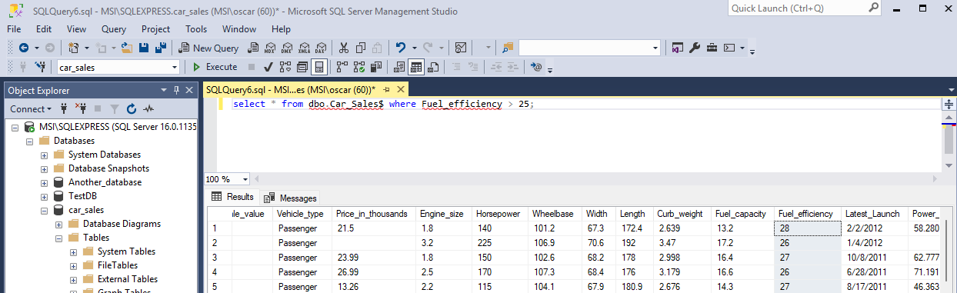
- Find all cars with a price greater than $20,000.
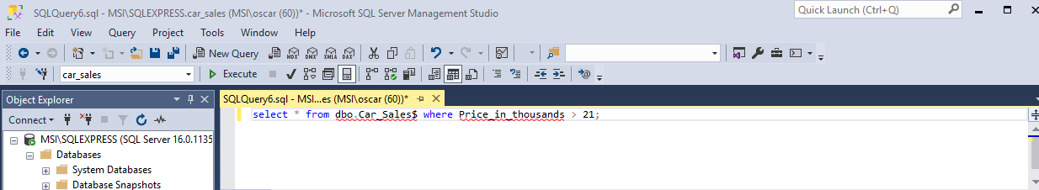
- Select all distinct car makes in the dataset.
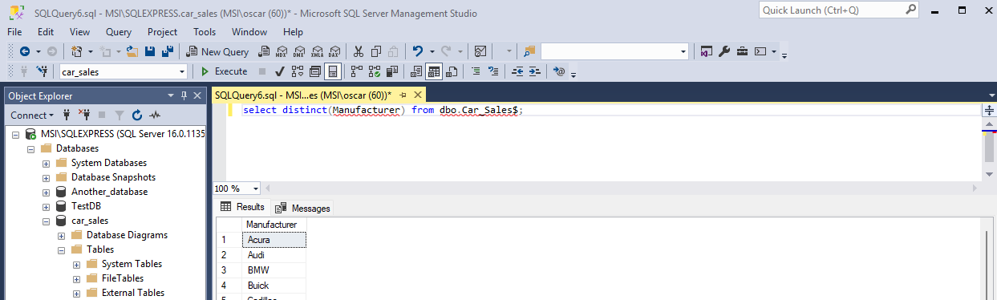
- Find the top 5 most expensive cars.
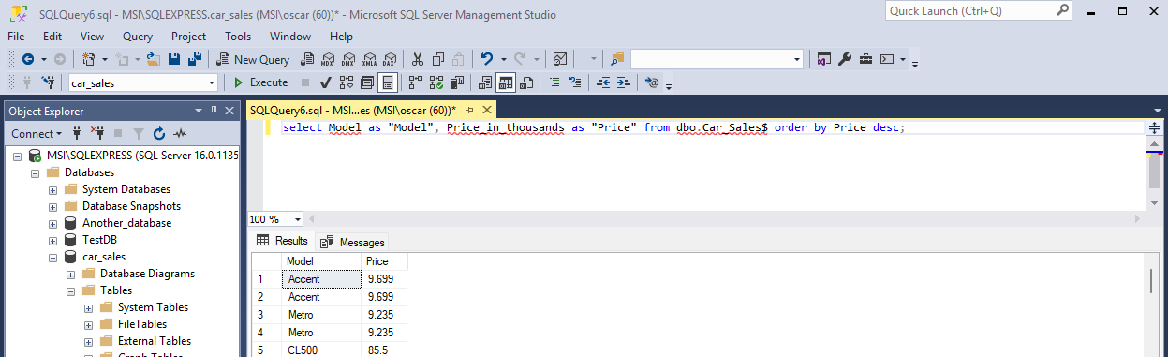
- Retrieve all cars with an engine_size greater than 2.0L.
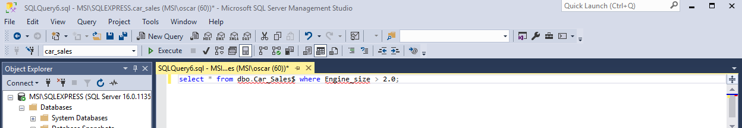
- Select the model, make, and price of the cheapest car.
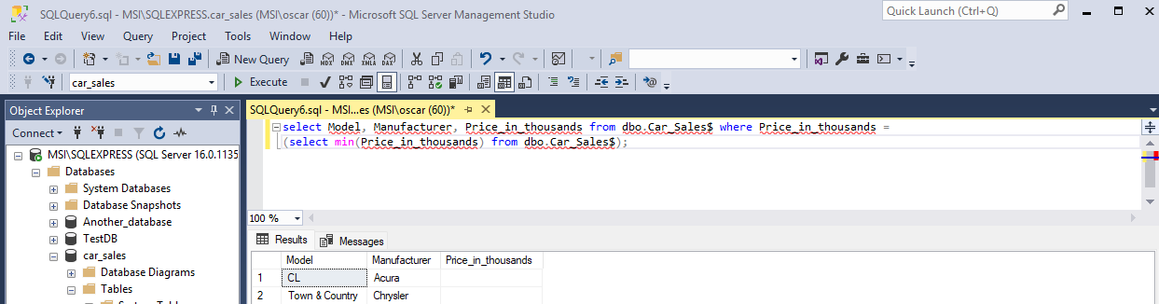
- Retrieve all cars with fuel type as 'Petrol'.
- Find all cars with a transmission of 'Automatic'.

Filtering Data
- Retrieve all cars from Toyota.
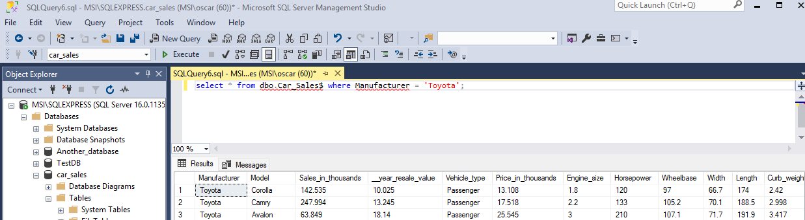
- Find all cars with mileage less than 50,000.
- Select all cars that are not SUVs.
- Retrieve all cars where color is 'Red'.
- Find all cars with more than 5 seats.
- Retrieve all cars made between 2015 and 2018.
- Find all cars with a price between $10,000 and $15,000.
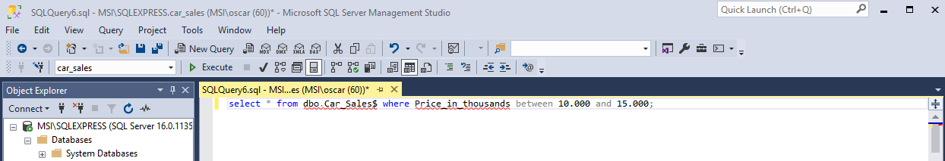
- Retrieve all cars with a fuel type of either 'Diesel' or 'Hybrid'.
- Select all cars where the engine_size is less than 1.5L.

- Find all cars where the model starts with 'C'.

Aggregation
- Find the total number of cars in the dataset.
- Calculate the average price of all cars.
- Find the maximum mileage of any car.
- Calculate the sum of all car prices.
- Find the minimum year a car was made.
- Count the number of cars by each make.
- Find the average mileage of SUVs.
- Calculate the total price of all Toyota cars.
- Find the average engine_size of all cars.
- Calculate the sum of all car prices for cars with a year of 2020.

Grouping and Aggregation
- Count the number of cars for each fuel type.
- Find the average price for each make.
- Calculate the total mileage for each transmission type.
- Find the maximum price for each model.
- Calculate the average year for each color.
- Find the sum of prices for each engine_size.
- Count the number of cars for each year.
- Calculate the total mileage for each make.
- Find the average price for each fuel type.
- Calculate the sum of all car prices for each transmission type.

Subqueries
- Find the make and model of the car with the highest price.
- Select all cars that are more expensive than the average price.
- Find the make and model of the car with the lowest mileage.
- Select all cars where the year is higher than the average year.
- Find the make and model of the car with the highest mileage.
- Select all cars that have a price greater than the average price for SUVs.
- Find the make and model of the car with the lowest price.
- Select all cars where the engine_size is higher than the average engine_size.
- Find the make and model of the car with the highest year.
- Select all cars that have a mileage less than the average mileage.

Joins
- List all cars and their respective seller's name.
- Find all cars sold by a specific seller.
- Select the make, model, and seller's name for all SUVs.
- Retrieve the model and price for all cars sold by sellers in 'New York'.
- Find the make, model, and price of cars sold by sellers with more than 10 cars listed.
- Select the make, model, and seller's name for all cars priced above $30,000.
- Find the make, model, and seller's name for cars with a mileage below 30,000.
- Retrieve the make, model, and year of cars sold by sellers in 'California'.
- Find the make, model, and seller's name for all Hybrid cars.
- Select the make, model, and year of cars sold by sellers with a rating above 4.5.

Advanced Queries
- Calculate the average price of cars sold by each seller.
- Find the total mileage of cars sold by each seller.
- Calculate the average engine_size of Hybrid cars.
- Find the most common color of cars sold by each seller.
- Calculate the average year of cars sold by each seller.
- Find the total price of cars sold by sellers with a rating above 4.0.
- Calculate the average price of cars sold by each seller in 'Texas'.
- Find the total mileage of cars sold by sellers in 'Florida'.
- Calculate the average engine_size of cars sold by sellers in 'Ohio'.
- Find the most common color of cars sold by each seller in 'Arizona'.

Window Functions
- Calculate the running total of car prices ordered by date_sold.
- Find the rank of each car by price within each make.
- Calculate the difference in price between each car and the average price for its make.
- Find the top 3 most expensive cars within each make.
- Calculate the cumulative mileage for cars sold ordered by date_sold.
- Find the lagged difference in mileage between consecutive cars sold.
- Calculate the lead difference in price between consecutive cars sold.
- Find the cumulative sum of prices for cars sold by each seller.
- Calculate the running average mileage for cars sold ordered by date_sold.
- Find the row number of each car sold within each make.

Data Modification
- Update the price of all cars that are more than 10 years old by reducing it by 10%.
- Delete all cars with a mileage greater than 100,000.
- Insert a new car into the cars table.
- Update the mileage of a specific car.
- Delete all cars with a price less than $5,000.
- Insert multiple new cars into the cars table.
- Update the color of all cars to 'Black' where the make is 'Ford'.
- Delete all SUVs with a price greater than $50,000.
- Insert a new car with specific details into the cars table.
- Update the engine_size of a specific car to 2.5L.

Data Analysis
- Find the average price of cars sold in the last year.
- Calculate the total mileage of cars sold in the last month.
- Find the most common make of cars sold in the last quarter.
- Calculate the average engine_size of cars sold in the last week.
- Find the total price of cars sold in the last day.
- Calculate the average year of cars sold in the last decade.
- Find the most common color of cars sold in the last year.
- Calculate the average mileage of cars sold in the last month.
- Find the total price of cars sold in the last week.
- Calculate the average engine_size of cars sold in the last day.

